31

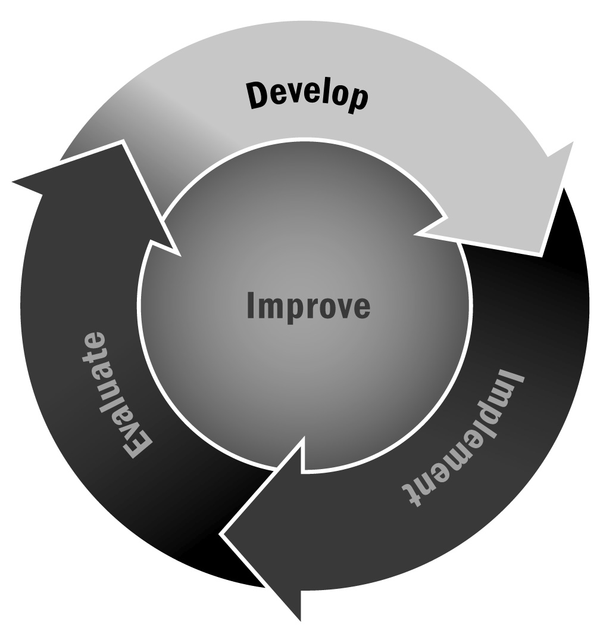
Communication Format Guidelines
In Chapter 1, you learned that a key component of effective communication is knowing your audience and method of delivery so that you can create content and a format that is appropriate and valuable.
Directions: Consider the following guidelines when formatting your communication for a variety of different messaging formats.

Guidelines for Formatting Your Message
Message Format | Guidelines | Suggested Content Ideas
Hard Copy
Letters home | - Share important information or updates.  - Maintain a focus and be specific—usually letters home are designed to let people know about one important topic.  - Always include the date and a signature at the end.  - Provide contact information in case people have follow-up questions. | - Beginning-of-year planning  - Upcoming events  - Emergency closing  - Change in program schedule  - Enrollment in new activities  - End-of-year planning
Newsletter | - Involve young people with design, writing content, and distribution.  - Have multiple sections for different content but try to keep those sections the same every time you send one out.  - Keep the information in each section short, sweet, and varied.  - Share pictures of different program activities. | - Program updates  - Upcoming special events  - Review of past events  - Special topics based on what young people learned during programming
Flyers and brochures | - Keep the message(s) short and to the point.  - Make it colorful and include one or two high-resolution pictures.  - Post or share in public places. | - Program enrollment  - Special events  - Fundraising
Electronic
Online newsletter | - Involve young people with design, writing content, and distribution.  - Have multiple sections for different content but try to keep those sections the same every time you send one out. Keep the sections short and sweet.  - Hyperlink to different organizations’ websites if you mention them.  - Always provide an option to unsubscribe or reduce the frequency of messages. | - Program updates  - Upcoming special events  - Review of past events  - Special topics based on what young people learned during programming
Email blast | - Always include a full and informative subject line. “Program Name – Calendar of Upcoming Events” is more likely to get someone’s attention than “Program Events.”  - Keep the language formal even though we often communicate in a more relaxed tone over personal email. Always start with “Dear,” “Hello,” or “To,” and end with “Sincerely,” “Best,” or “Regards.”  - Include a signature at the end of all emails that has important contact information such as your name, email address, and phone number. | - Beginning-of-year planning  - Upcoming events  - Emergency closing  - Change in program schedule  - Enrollment in new activities  - End-of-year planning
Facebook | - Share “exclusive information” in addition to basic updates. Use social media as a platform for unique information that you can’t find on your website or in a newsletter.  - Post frequently if you have updates to share.  - Make sure that what you post is relevant and useful for your program and the field you are in.  - Use engaging and high-quality photos when you post but make sure you have permission first, especially if they are of young people.  - If you have a website, use links in your posts that will drive people to that page. | - Non-urgent program updates  - Short, funny stories and anecdotes  - Photos of youth enjoying the program  - Reminders of upcoming events  - Questions or things to think about
Twitter | - Your message cannot be longer than 140 characters, so be concise.  - Tweet what is relevant and useful for your program and the field you are in.  - Tweet often—at least once a day—as long as you have something relevant to share.  - Use shorter hyperlinks if you want to share. Many sites (like http://tinyurl.com) can shorten longer hyperlinks for free.  - Encourage dialogue. Ask questions when you tweet, and encourage other Twitter users to retweet your posts.  - Use #hashtags to identify posts about a specific topic. Make one up for your program and encourage others to join the conversation.  - Add a link to your Twitter feed in your program’s email and on your website. Twitter provides these tools for free through the site. | - Non-urgent program updates  - Photos of youth enjoying the program  - Reminders of upcoming events  - Questions or things to think about  - Responses to others about topics that are relevant to your program and the afterschool and expanded learning field more broadly

